***LAB 1: DIGITAL IMAGE PROCESSING***

***SUBMITTED BY:***

***M. SULEMAN HAMDANI***

***349220, BSCS 10B***

# TASK 1 – ADDITION:

# TASK 2 – Buylotsoffruits

# TASK 3:

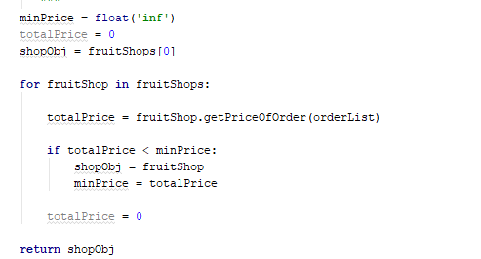

# AUTO-GRADER:

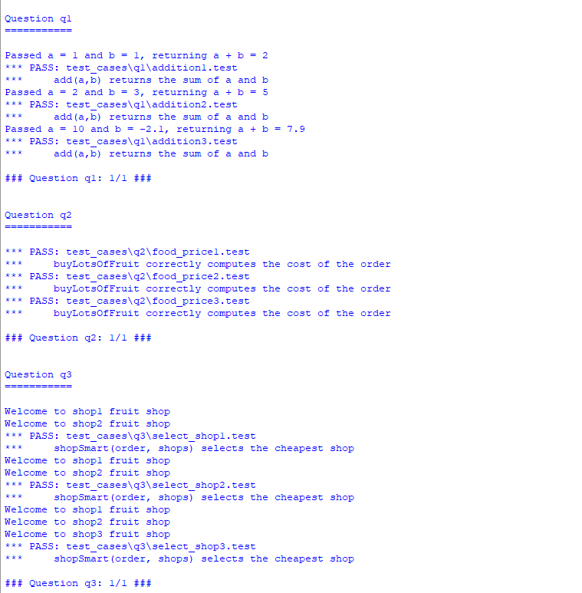

# part ii – task 1

## code:

## OUPUT:

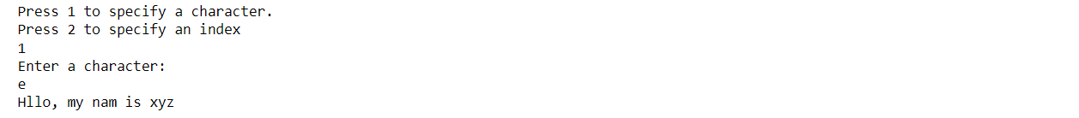

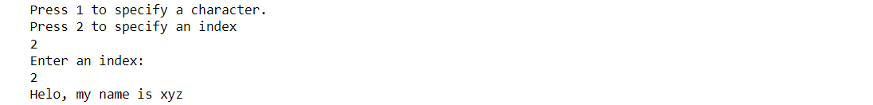

# PART II – TASK 2

## CODE:

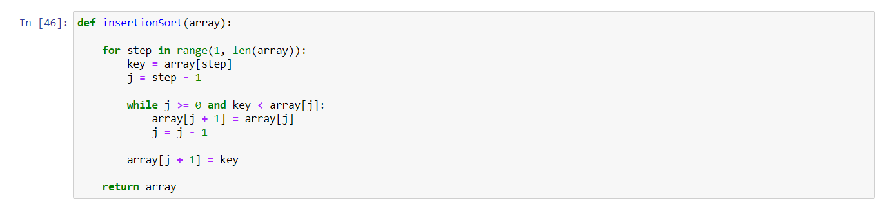

## OUTPUT:

